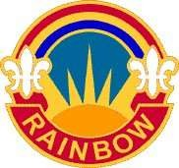

The RAINBOW Bugler

*Publication of the 42d Infantry “Rainbow” Division Association*

Vol. 38 15 July 2024

**Board of Directors**

**President Pat Alesia Vice President Frank Ombres Hudson Valley C/C Frank Degano**

**Downstate C/C William Vorlicek**

**Secretary Vacancy**

**Treasurer Frank Sasiadek**

**Alternate Ex. Comm. Members**

**Nominations**

**By-Laws Comm Thomas Principe Historians Paul Schottenhamel**

**Webmaster Donald Roberts Dwn. St. Chap., VP Steve Oleksak Dwn. St. Chap., Sec Hank Zalak**

**H. V. Chap., VP Jennifer Rivera**

**H. V. Chap., Sec Sal Mongiovi**

**H. V. Chap., Treas. Paul Gross**

**NEXT BOARD OF DIRECTORS MEETING AT KING UMBERTO’S, 1200 HOURS.**

**14 AUGUST 2024**

**TAPS**

Jan’24 to Jul ’24 Roll

**Michael Guglielmo: 23 Jan 24  
Vincent Puleo: 27 Mar 24  
Henry Speicher: 26 May 24**

**John Lock: 3 July 24**

**HUDSON VALLEY CHAPTER MEETING SCHEDULE**

**Location: FINO’s RESTAURANT**

**1 Baltic Place, Croton, NY**

**Lunch Cost: $30.00 per person**

**Wednesdays, 18 September 2024.**

**5 Feb, 7 May, 17 Sep, 10 Dec 2025**

**Meeting 1200 Hours**

**RSVP: Chapter Secretary**

Sal Mongiovi (914) 469-5310

1115 Frost Ln, Peekskill, NY 10566 [MongioviSalvatore@hotmail.com](mailto:MongioviSalvatore@hotmail.com)

### DOWNSTATE CHAPTER MEETING SCHEDULE

**Location: Frank’s Steak House**

**54 Lincoln Ave., Rockville Centre**

**Wednesdays, 18 Sept 2024**

**19 MAR, 11 JUNE, 17 SEP 2025**

**Location TBA**

**Cocktails: Noon– Meeting 1300 hrs**

**RSVP: Chapter Secretary**

**Hank Zalak** (917) 571-9471

61-35 75th Place, Middle Village, NY 11379 [Hzalal@aol.com](mailto:Hzalal@aol.com)

This NEWSLETTER is published two times a year on 15 Jan and 15 July respectively by the Secretary, 42d Infantry “RAINBOW” Association, c/o 155 Locust Street, Valley Stream, NY 11581

~~.~~**Individual Annual Dues: $25.00**.

The BUGLER does not carry paid advertisements. **Pg. # 1 of 11**

# President’s Message

Hope all is well! As our weather becomes warmer and the humidity becomes higher let’s hope that our Summer brings joy and happiness to our Rainbow Family.

Once again, thanks to Bill Vorlicek for planning and organizing our Memorial Day Ceremony at our WWI Monument in Garden City. Col Lou DiLeo performed his beautiful rendition of the singing of our National Anthem, and played Taps. The 11th New York Regiment provided the Color Guard and Firing Detail. Thanks to BG(R) James Whalen, Chaplain Mark Getman, and Bert Cunningham for their help and support. Special thanks to all the Downstate Members who were in attendance.

I was honored to represent our Association at the annual Hofstra Army ROTC Spring Awards Ceremony on 10 May. The 42d Infantry Division Association award was presented to MSIII Cadet Anthony Trevino. Thanks to Joe Schroder who prepared the certificate and ribbon for presentation. (See Joe’s report)

I remind all that our upcoming West Point Golf Outing will take place on Monday 29 July. (See our Golf Flyer)

In addition, our Association Holiday Luncheon will take place on Saturday 16 November At Russo’s On The Bay from 1:00-6:00pm. Please Save The Date!

Our Chapter Meetings continue to be well attended; with guest speakers making outstanding presentations on current topics.

Special thanks to Sal Mongiovi for stepping up and taking responsibility for publishing our Rainbow Bugler.

Looking forward to seeing all at Chapter Meetings!

Rainbow 🌈 Never Forget!

God Bless All and God Bless America

Pat Alesia

## 142d INFANTRY “RAINBOW” DIVISION ASSOCIATION MINUTES OF THE BOARD OF DIRECTOR’S MEETING

1. Today’s meeting was conducted at King Umberto’s Restaurant, 1343 Hempstead Tpke., Elmont, NY. This meeting was called to order at 1200 hrs. (Noon) by Association President, Pasquale A. Alesia, BG(R).
2. **Roll Call:** Those in attendance were:

|  |  |  |
| --- | --- | --- |
| **ASSOCIATION** | **Down State Chapt.** | **Hudson Valley Chp** |
| Pasquale A. Alesia, Pres  Frank Sasiadek, Treasurer | Bill Vorlicek, C/P | Frank Degano, C/P |

Frank Ombres, V/P

**Holiday Luncheon: The following issues were finalized:**

a- Attendees: D/S Chapter, H/V Chapter, Gold Star Family Members, American Legion Post 694, Veteran Groups

b- Bus Transportation: D/S Chapter paid in full; H/V Chapter balance due: $1000- Association check

c- Sequence of Events: Posting of Colors, National Anthem, Invocation, Fallen Comrade Ceremony, Toasts, Introduction of Gold Star Family Members, Veterans, and Sponsors, Lunch, Award Presentations, Visit from Santa and Elf, Entertainment, Benediction.

1. **Adjournment:** There being no further business to come before the Board, **Frank S.** made a “Motion to Adjourn” which was seconded by Bill V**.** The motion was accepted by a vote of**: 6-0** and President Alesia adjourned the meeting at **1345 hours.**

Respectfully submitted,

Pasquale A. Alesia , President

# TREASURERS REPORT

Basically, we stared the year with $19,840.00 in checking and $17470.00 in savings. There have been some checks written to cover early

costs for the up coming Golf outing and the Holiday Luncheon. We have also collected money for the two mentioned events. We currently

have $27090.00 in checking with savings remaining the same.

# SAVE THE DATE:

Our Annual West Point Golf Outing will be held on **29 July, 2024**

**If you plan on joining us on Monday, 29 July, 2024 you will need to get your PAID reservations in as soon as possible after you receive this year's FLYER. Looking forward to seeing all on the 29th of July.**

### VETERAN’S PRAYER

**Dear Lord, I’ve served my Country, My love for her is strong.**

**I’ve stood behind “Old Glory”... When others thought her wrong.**

**I’ve joined in celebration And raised a toast in cheer. I’ve pledged her allegiance and sung her anthem dear.**

**I’ve wept for fallen comrades Who proudly fought and died,**

**The freedoms they defended. I cherish deep inside.**

**I’m proud to be an American For her strength and peace I pray.**

**There is no greater country...**

## God Bless the USA!

Downstate Chapter Chairperson Corner

Greetings from the Chair.

It is hard to believe that 2024 is half over!

The Downstate Chapter had a very productive first half. We had 2 luncheons that were enjoyed by all.

We also conducted the Annual Memorial Weekend Wreath Laying Ceremony at the Division Monument in Garden City. Thanks to the Village who provided seats for us. Thanks also to the 11th New York Regiment (United States Volunteers-America) for providing the Color Guard, Firing Party, Bugler and singer for the National Anthem. Thanks to all of the Chapter members who attended. Of note, for the first time the Division Headquarters assigned a current member of the Division to assist in placing the wreath. SFC Nick Velazquez of the 42d Infantry Division Main Command Post - Operational Detachment assisted in presenting the wreath along with SFC Colin Stewart of Co B 1-69 Infantry Regiment who has assisted us in the past.

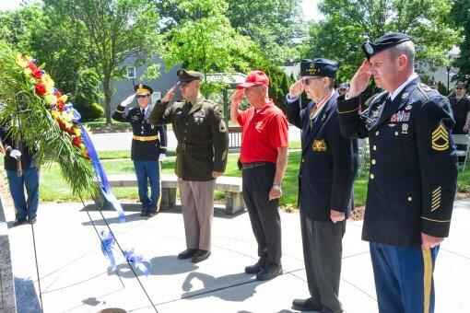

From left to right, SFC Velazquez, BG (R) Alesia, Bert Cunningham and SFC Stewart

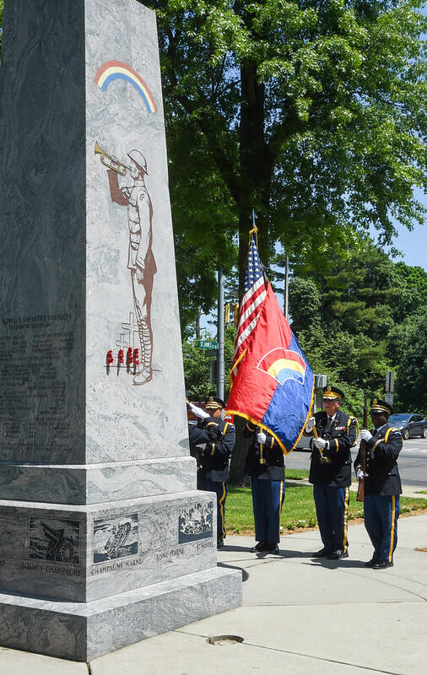

Color Guard from the 11th Regiment

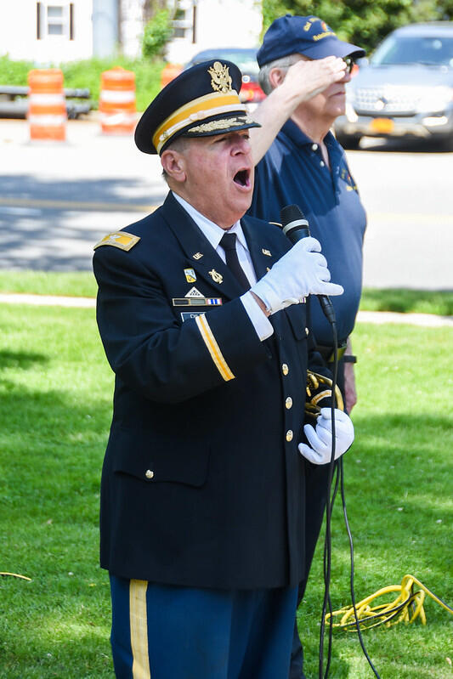

Colonel Louis DiLeo singing the National Anthem.

Please mark your calendars for the Veterans Day Wreath Laying Ceremony scheduled for Saturday November 9th 2024 at noon. Hope to see everyone there.

Also mark your calendars to attend the Association’s Annual Holiday Luncheon. It is booked for Saturday, November 16th 2024 at Russo’s on the Bay in Howard Beach. Starting at 1:00 PM and going to 6:00 PM. Due to last years large turnout, Russo’s has given us the largest room they have. The Planning Committee has started planning the agenda. The plan is to conduct the awards presentations at the beginning in order to maximize the enjoyment of the luncheon. The same DJ has been hired and he has promised a few surprises. The plan is to also have Michelle Della Fave come back and perform the Patriotic medley that she did last year. Plus there is a rumor that not only is Santa and elf Booby going to be there but Mrs Claus and Elf Ronni will be coming also.

Russo’s has once again given us the Veterans discounted price of $75.00 per person. The Association covers the dinner cost for all the invited veterans, Gold Star families and like last year we are inviting members of the Military Order of the Purple Heart. To help offset the cost to the Association, we started a Sponsor a  Veteran  program. The goal is for each Chapter member to sponsor a veteran or Gold Star family member to attend the luncheon. At the June Chapter luncheon, 3 Downstate members agreed to sponsor an individual each. The hope is that we also increase the Chapter membership attendance. The event is really a great time to renew old friendships while meeting new veterans and Gold Star families. I am hoping that our Chapter participation increases. I ask that you consider inviting family members to attend. We actually have seen a large increase in grandchildren coming to the luncheon. Last year, the DJ sponsored a treasure hunt for kids with a $50 prize. The kids really enjoyed the day.  Unlike the old days, no military business was conducted and we didn’t get to enjoy the event. Now the “MISSION“ is to enjoy ourselves - eat, drink and be merry.

We will be sending out a flyer at the end of this month after the Golf Outing .

Thanks for your continued support and I hope to see everyone at the Luncheon.

RAINBOW- NEVER FORGET

Bill





Subject: 42nd Infantry “Rainbow” Division Awards for the 2023 School Year

This year on behalf of the 42nd Infantry “Rainbow” Division Association, I was able to present eight 42nd Rainbow Division certificates and 42nd Rainbow Division ribbons to very worthy Reserve Officer Training Corps (ROTC) and Junior Reserve Officer Training Corps Cadets.

The awardee selection is very simple. We only present awards to the Best Cadets at each University or Senior High School. Awardees are selected by the Professor of Military Science for University Senior ROTC and the Senior Instructor for High School JROTC. The criteria is:

“For Demonstrated Exceptional Ability in Academic Studies, Potential for Military Leadership and Citizenship as a Member of the Senior/Junior Reserve Officer Training Corps”. Our awards are signed by our President BG Pasquale Alesia.

Speaking to the cadet classes and awardees is a very rewarding personal experience for me as the award presenter. This year the following awards were presented.

I was also able to present two JROTC awards down here in South Carolina.

20 April 2024 Hofstra University ROTC Cadet Louis Velez

18 April 2024 Ft. Hamilton HS JROTC Cadet Owusu Collins, JR.

9 May 2024 Carolina Forest HS JROTC (SC) Cadet Connor Flanagan

16 May 2024 Conway HS JROTC (SC) Cadet William Rugamas

14 May 2024 Wyandanch Memorial HS JROTC Cadet Katia Perura

22 May 2024 TR Roosevelt HS, Bronx JROTC Cadet Ibrihim Sawadogo

23 May 2024 Uniondale HS JROTC Cadet Jonathan Bennett

5 June 2024 Lindenhurst HS JROTC Cadet Sgt. Kayleigh Hubschmidt

If any member would like to make a presentation at a local school JROTC program, please feel free to contact me at Ltcjoe118@gmail.com and/or 516-398-0171.

Joe Schroder