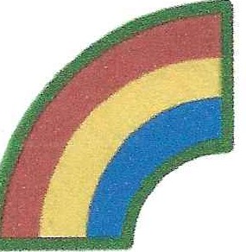

**42d Infantry RAINBOW Division Association**

ANNUAL HOLIDAY LUNCHEON

November 18, 2023

12 Noon TO 5 PM

**RUSSO’S ON THE BAY**

162-45 Cross Bay Boulevard

Howard Beach, NY 11414

718-843-5055

VALET PARKING

CASH BAR

Cost Per Person $65.00

Make Checks Payable to 42D INFANTRY RAINBOW DIVISION ASSOCIATION

RSVP NLT: 27 SEPTEMBER 2023

[No seating at the Door]

************************************************************

NAME: ____________________________________________

# GUESTS _____________ x $65.00 TOTAL AMOUNT $ ____________

SIGNATURE: ______________________________

MAIL TO: FRANK SASIADEK, 64-70 214TH Street

Bayside, NY 11364